Demonstration of Regular Proxy Management Process
Contents

1．Proxy Platform Introduction & Basic Functions 1
2．Login Interface 2
3．Homepage Display 3
4. Sub Proxy Distribution Management 4
4.1 Create Sub Proxy 4
4.2 Set Sub Proxy Profit Rebate 5
4.3 Assign Card 6
4.4 Balance&Add coupon 7
5.Ordering Plan/Change Plan/Renewal Plan Operations 8
5.1 Ordering Plan 8
5.2 Change Plan 8
5.3 Renew Plan 9
5.4 Other Functions 10
6.Order Management 10
6.1 Platform Orders 10
6.2 Renewal Order 11
6.3 Recharge Order 12
6.4 Consumer Order 12
6.5 Global Plan Change Order 13
7.Log Management 13
7.1 Login&Operation Log 13
7.2 Sale Order 13
7.3 SMS Log 14
8.Promotion Campaign Planning 15

1．Proxy Platform Introduction & Basic Functions
YueChuang Proxy Management Platform is a comprehensive IoT SIM card management system that supports SIM cards from China's three major domestic carriers and various international cards. It provides comprehensive functional services including viewing, transferring, ordering, profit-sharing, and renewal services, making it a true one-stop IoT management platform

2．Login Interface
Proxy management backend login website (recommended to open with Google Chrome): https://card.yourchat.top/#/proxy
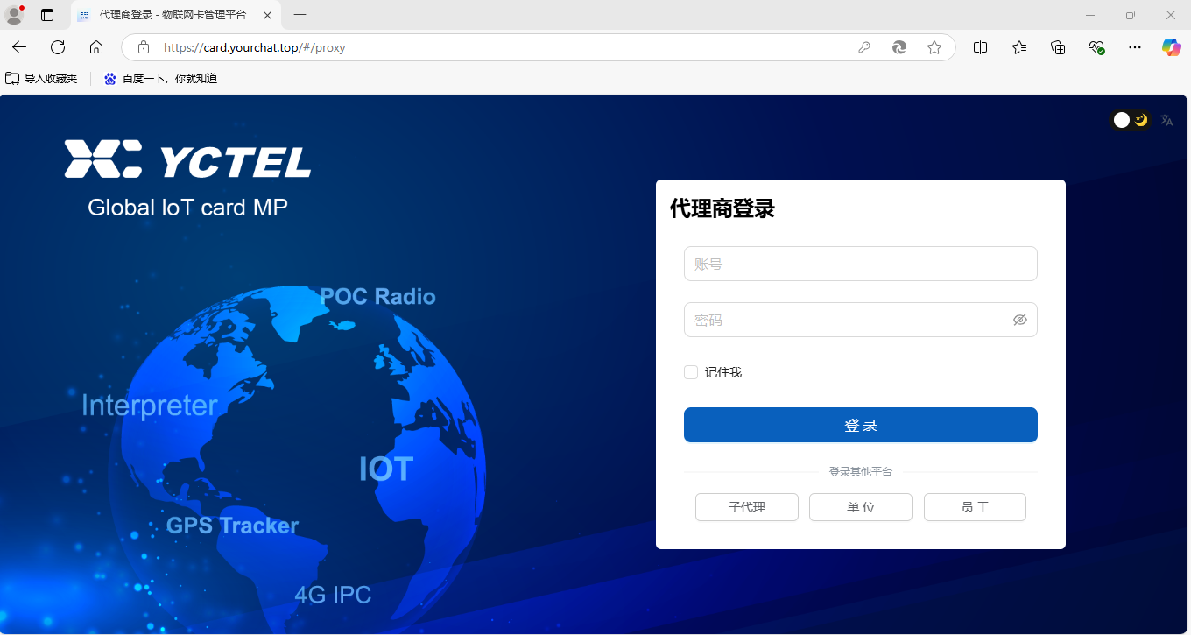

3．Homepage Display

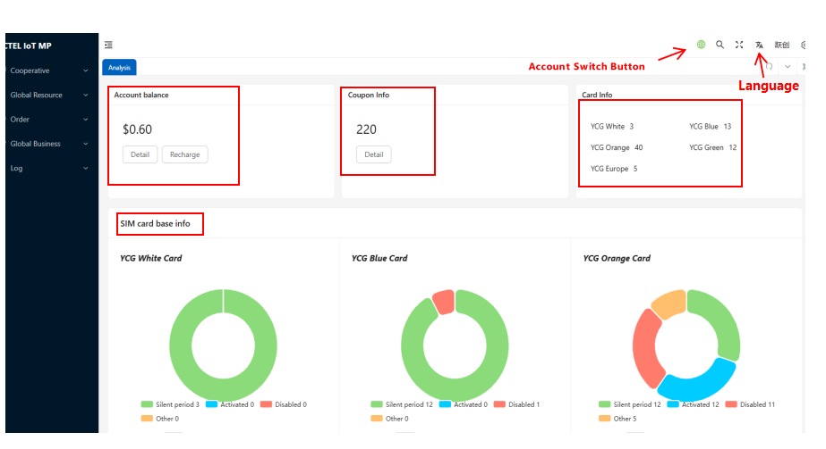Account balance operation interface
Details: View current account's recharge and expenditure details
Recharge: Self-service recharge in YueChuang's management backend, instant processing without manual intervention
Coupon infor : View platform coupons' issuance and usage
Card infor: View the inventory cards under the account that have not activated packages yet
SIM card basic info: View pie charts of various card types
Account Switch: When the icon is green, the current account is in USD (all plan orders/renewals will be priced in USD). When black, the account is in RMB (all plan orders/renewals will be priced in RMB). Note: USD and RMB plans have separate pricing (not direct conversion) - please verify with your account manager
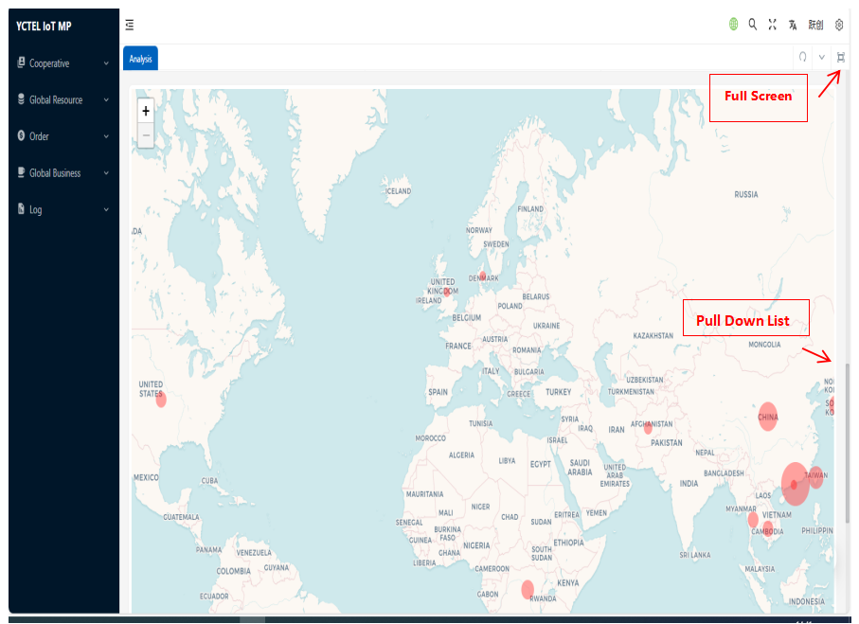
The right-side dropdown on the analytics page shows a world map, displaying statistics of countries already activated under the proxy's account (data comes from countries selected during plan ordering). Red dots represent countries with currently activated cards - click to view card details.
Full-screen button in the top right corner for convenient viewing.

4.Sub Proxy Distribution Management

4.1 Create Sub Proxy
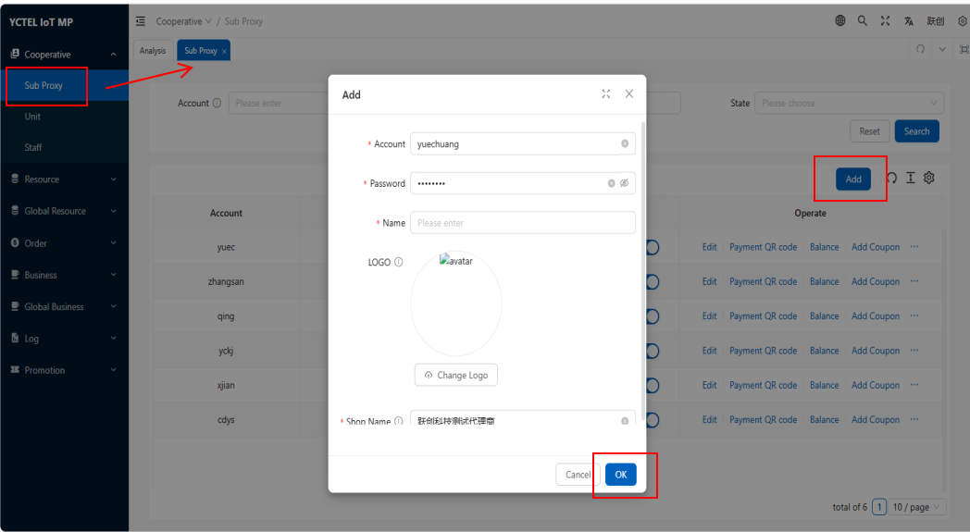
Click "Cooperative"---"Sub Proxy" --- "Add" --- Enter account, password, name, upload image and edit store name.

4.2 Set Sub Proxy Profit Rebate
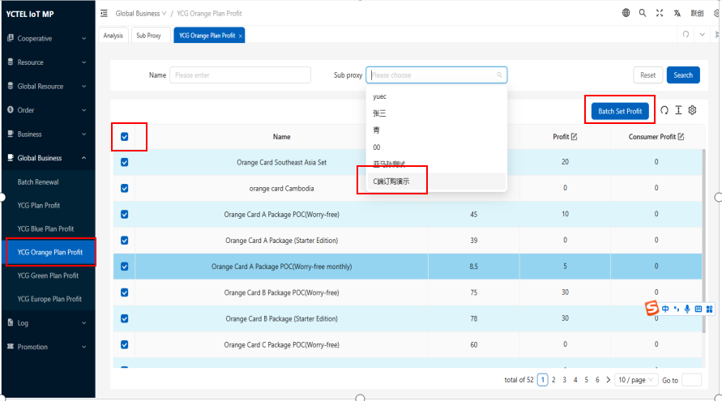
Click "Globall Business" --- Select the card types frequently used by this sub proxy --- Choose the sub proxy account --- Select all or individual plans --- Click "Batch Set Profit".

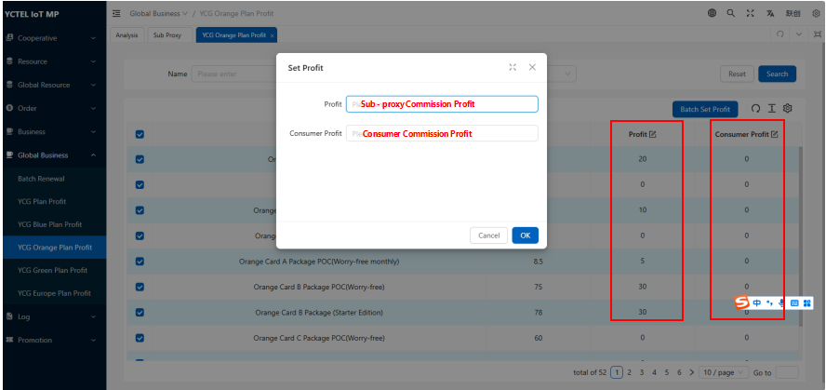
Popup window allows setting profit rebates for：
When sub proxy orders/renews plans themselves
When consumer orders/renews plans themselves
Note: If switched to USD account, USD rebates can be defined.

4.3 Assign Card
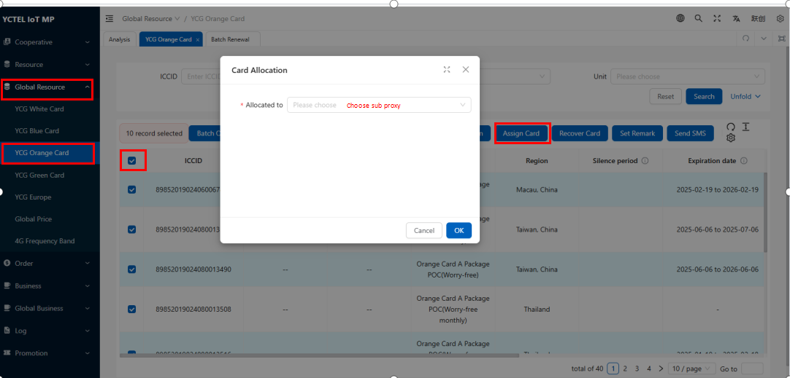Click "Global Resource" --- Select card type ordered by sub proxy --- In ICCID field, enter card number connected by # (898XXXXXXXXXXX001#898XXXXXXXXXXXXX009) to filter cards --- Select all --- "Assign Card" --- Choose sub proxy account
After assign, sub proxy can manage their own cards when logged in

4.4 Balance&Add coupon
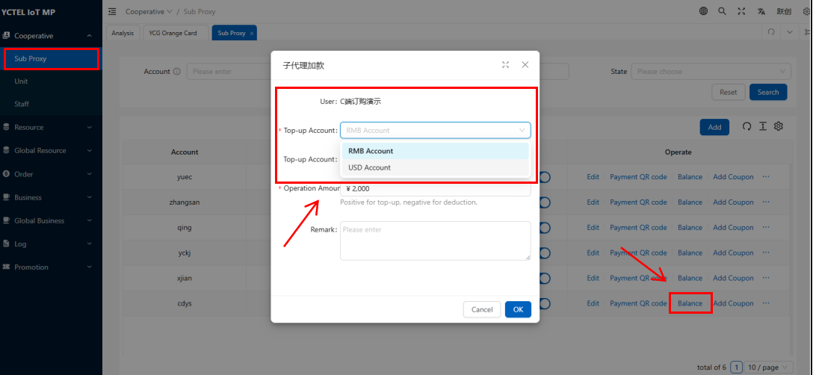
Top-up:
Click "Cooperative" --- "Sub Proxy" --- Select sub proxy needing funds --- Choose currency --- Enter amount --- Confirm.
Note: After sub proxy makes payment to the proxy , the proxy adds funds to sub proxy's account. Sub proxy can use these funds to order/renew plans. Profit from each plan will automatically return to proxy's platform
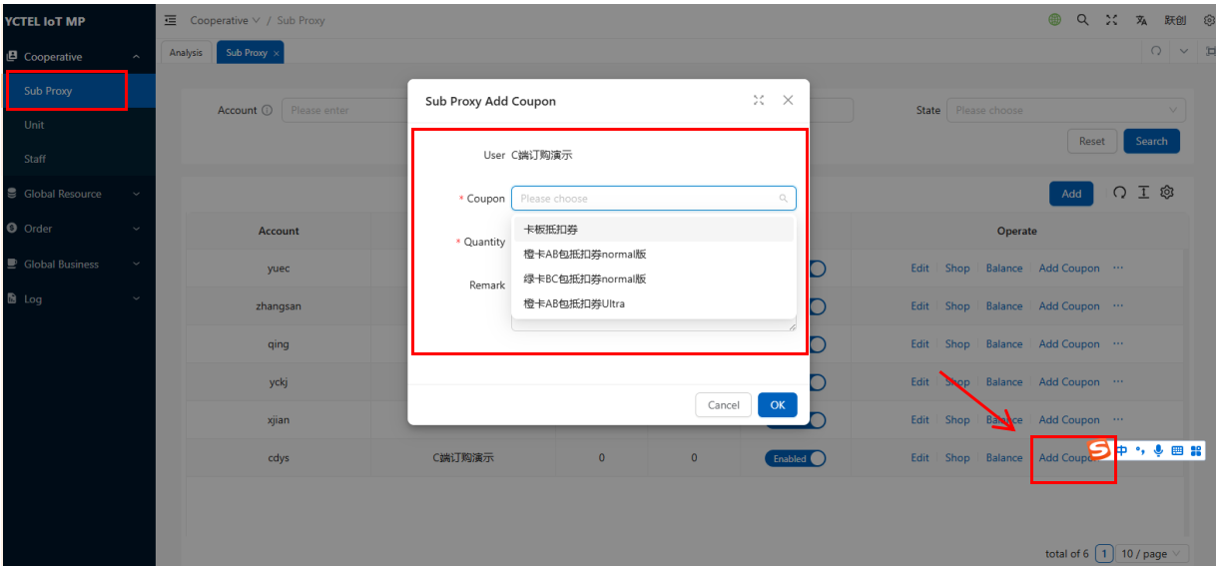
Add Coupons:
Click "Cooperative" --- Sub Proxy" --- Select sub proxy needing coupon --- Choose coupon --- Enter quantity --- Confirm.
Note: Coupons obtained by proxy can also be shared with sub proxy to reduce ordering costs, while maintaining the proxy's profit share.

5.Ordering/Change Plan/Renewal Operations

5.1 Ordering Plan
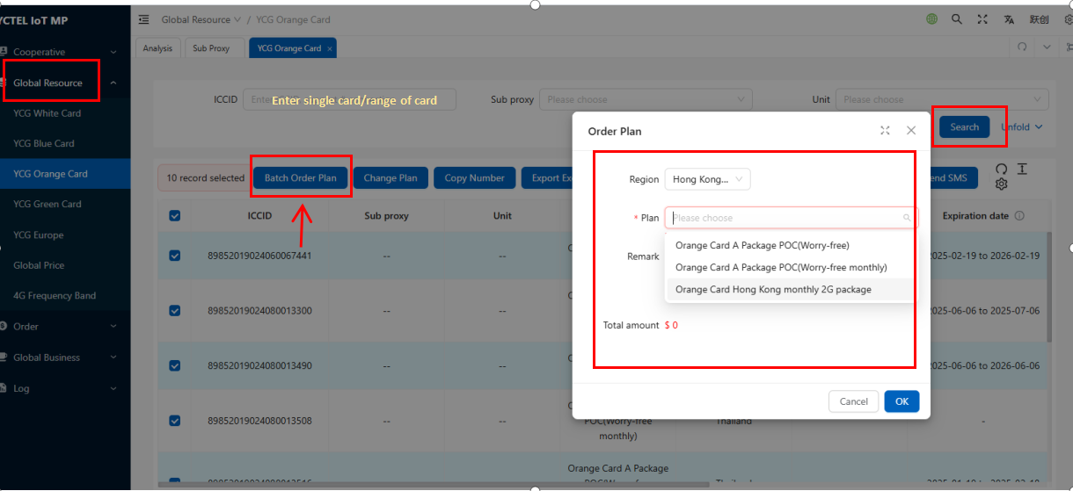
Click on the card type to order --- Enter single card/range of card numbers --- Select cards --- Click "Batch Add Plan" --- Enter region --- Search and select plan --- Choose discount coupon --- Confirm payment.
Note: Card coupons can be applied to every card (remember to select). Discount coupons are specific to certain plans only (check with account manager for coupon eligibility).

5.2 Change Plan
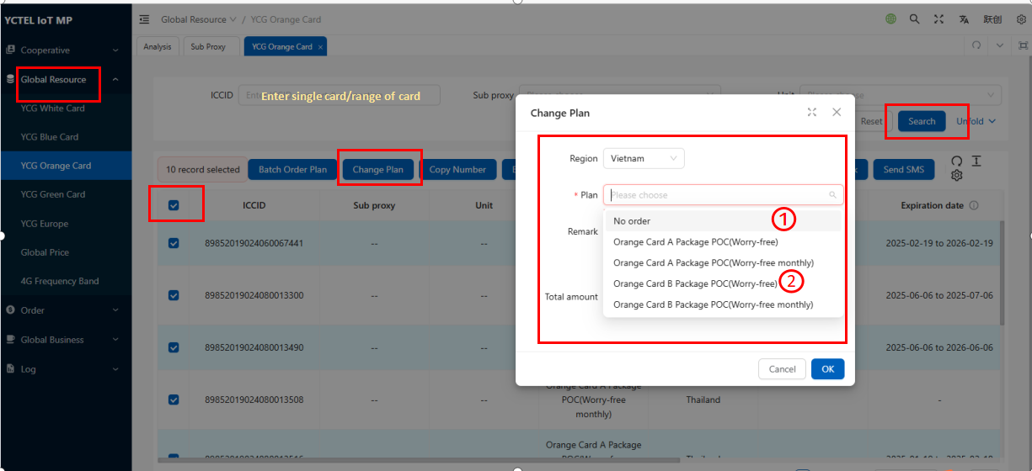

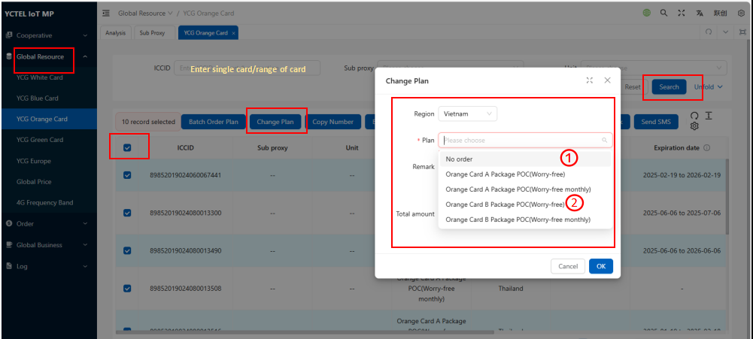Click on the card type to change --- Enter single card/range of card numbers --- Select cards ---Click "Change Plan"--- Enter region --- Search and select new plan --- Confirm payment.
Change Scenario 1: For product returns, directly change card plan to "no order" status. The card can then be reordered with a new plan (new start/end dates).
After the change, unused amounts from original plan will be refunded to platform account the next day. If original plan wasn't activated, full refund will be issued.
Change Scenario 2: When the original plan's region or carrier doesn't meet user needs, directly switch to a suitable plan. The plan start/end dates remain unchanged (same as original plan).
After the change, unused amounts from original plan will be refunded to platform account the next day. If original plan wasn't activated, full refund will be issued.

5.3 Renew Plan
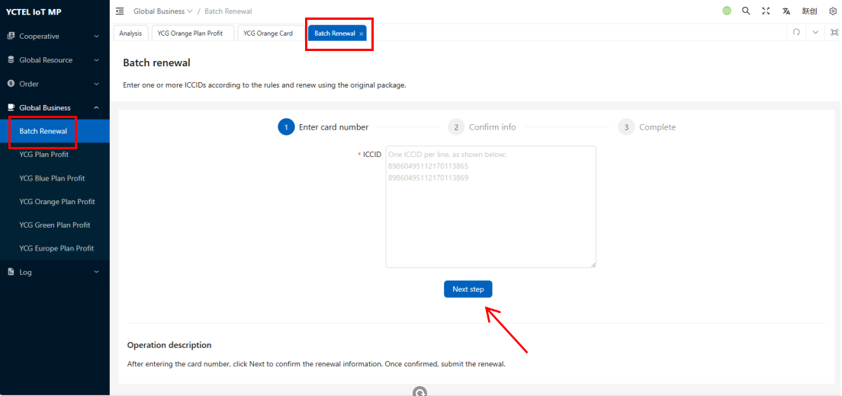
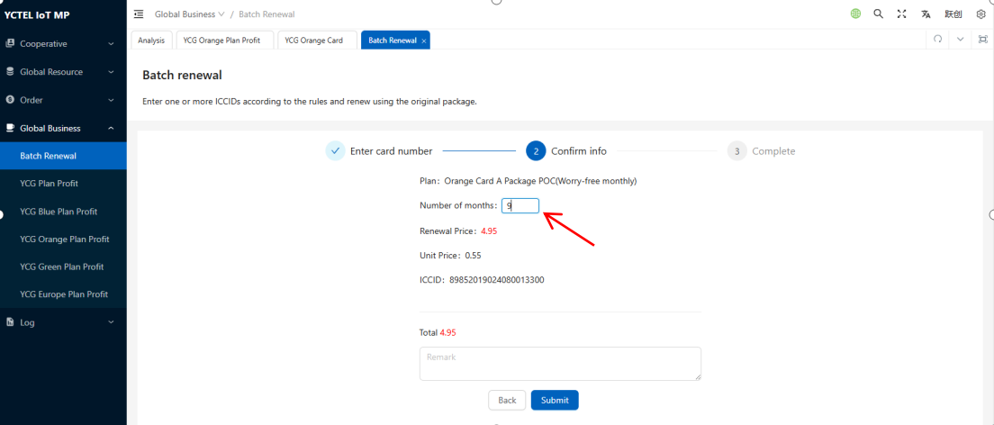
Click on the card type to renew --- Enter single card/range of card numbers --- Search --- Select cards ---Click "Renew Plan" ---Proceed to renewal interface --- Click "Next" --- Confirm months --- Submit ---Payment processed.
Note: Default renewal period matches original plan duration (e.g., if original was annual plan, defaults to 12 months). Can manually adjust months (e.g., renew for 9 months). Billing formula: Monthly plan price × months.

5.4 Other Functions
:Batch select numbers then batch copy card numbers



:Batch select numbers then export card information list
copy card numbers

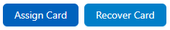
:Batch select numbers then assign/recover to
sub-proxy or main platform

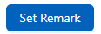
:Batch select numbers then add notes to cards
numbers

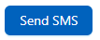
:Batch select numbers then send SMS (currently limited to certain card types - confirm with account manager)

6.Order Management

6.1 Platform Orders
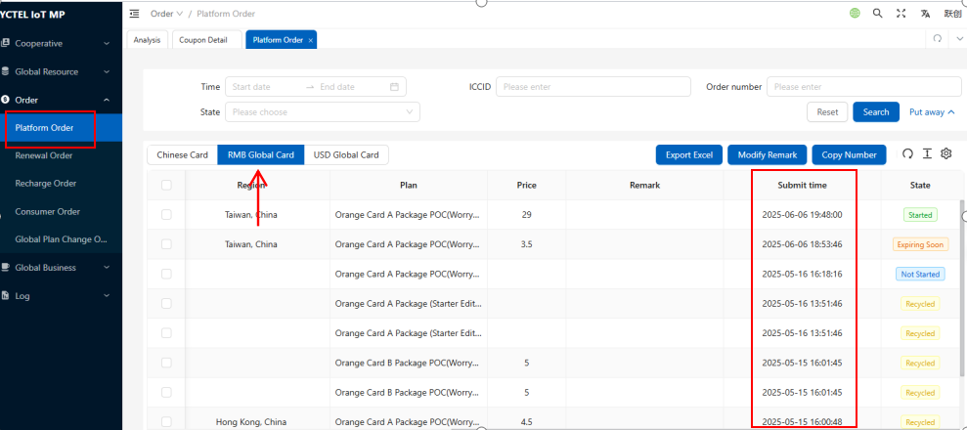
Click "Order " --- "Platform Orders"--- RMB Global Cards
View all plan orders under the account. Filterable by submission time, ICCID, order number, status

6.2 Renewal Order
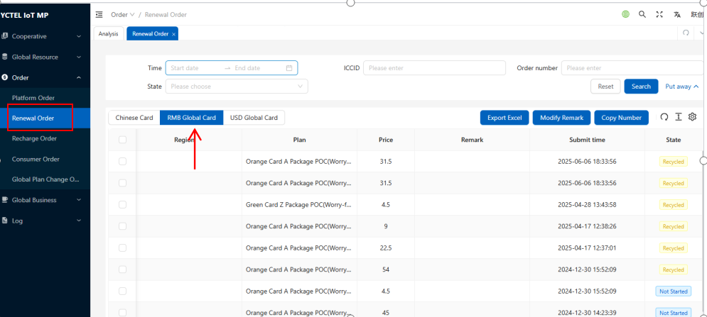
Click "Order " --- "Renewal Orders" --- RMB Global Cards
View all plan renewals under the account. Filterable by submission time, ICCID, order number, status.

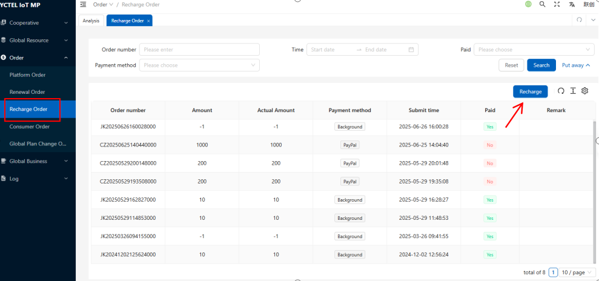
6.3 Recharge Order
Click "Order Management" → "Recharge Orders"
View account recharge records. Direct recharge also available on this page.

6.4 Consumer Order
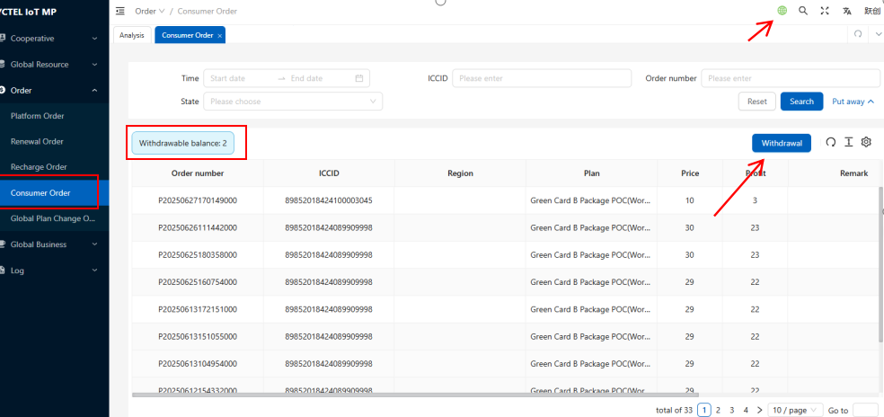
Click "Order " → "Consumer Order"
Switch to Global (USD) version in top right corner to view orders placed/renewed by users. Withdrawal available. Details will be explained later in a dedicated document.

6.5 Global Plan Change Order
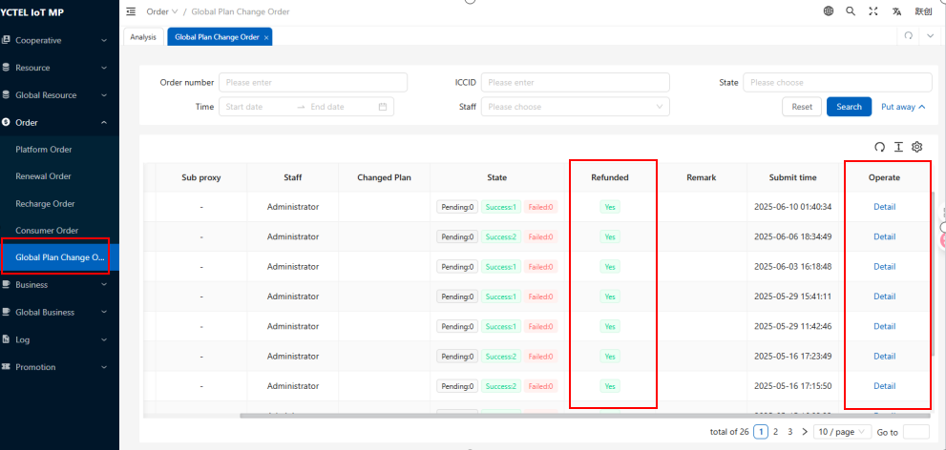
Click "Order" → "Global Plan Change Order "
View all plan change work orders. Click details to see card numbers, original plan, order amount, days used. Also shows if refund was processed.

- Log Management

7.1 Login&Operation Log
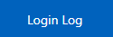
：View login IP addresses to prevent unauthorized access.

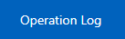
: View which IPs performed card transfers, fund transfers, or added sub-agents.

7.2 Sale Order

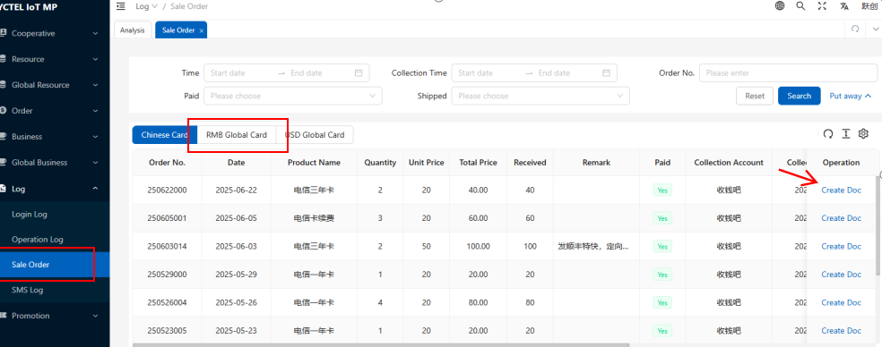
Click "Sales Orders" to view transaction records with YueChuang for domestic cards/RMB Global cards/USD Global cards.
Smart categorization: Filter by Date, payment time, order number, shipment status, payment status.
E-order generation: Paperless workflow with electronic orders.
Data synchronization: Real-time bilateral updates with YueChuang for clearer accounting.
This is the industry's first intelligent CRM order management system for IoT supply chains, ensuring transparent business operations.

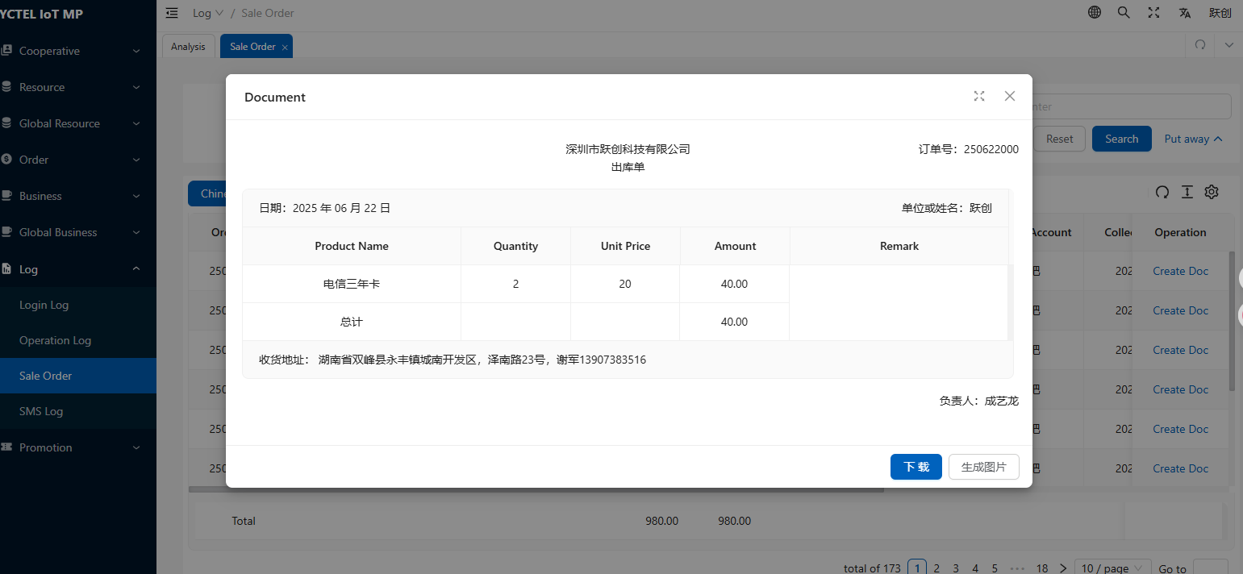
E-Order Example

7.3 SMS Log

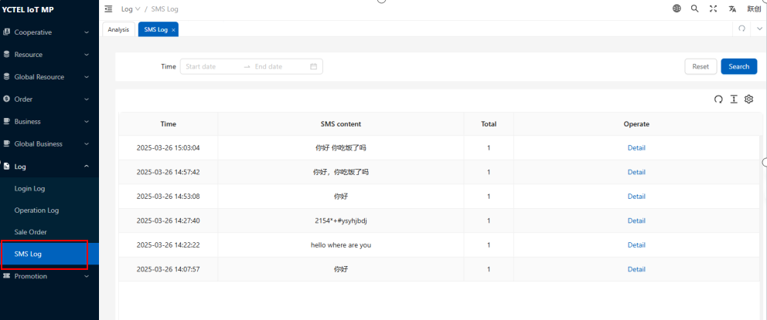
View sent SMS content details (only supported for certain card types)

8.Promotion Campaign Planning
Coupon Details:
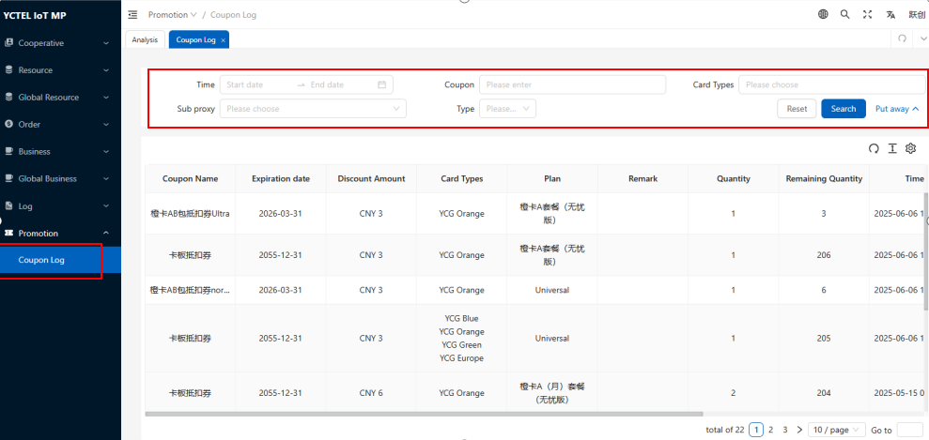
View all coupon transactions under the account. Filterable by time, coupon name, applicable card type, sub proxy, and type.

